**Measuring Conversion**

**1) INTRODUCTON :**

**a) Definition of conversion :**

‘*If a customer performs a desired action then it is called a conversion for a marketer*’.

Ex : Buying a product, Responding to emails, Registering or Subscribing in a website, Downloading content etc…

**b) Metrics :**

* Conversion is measured by conversion Rate.
* **Conversion Rate :**

Conversion Rate is defined by *Ratio of No. of Goal Achievements to total no. of visitors to a site.*



**c) Aim :**

* Conversion aims to solve the issue of low online conversion rate through different optimization techniques.

**2) MARKET CONVERSION OVERVIEW:**

* To achieve market conversion a combination of personalized customer experience, web analytics & customer feedback are required so that we can improve the customer usage flow and site design.
* Conversion techniques will generally give profitable results in long-term run rather than a quick fix to a problem.
* Market conversion primarily focuses on driving the existing customers towards a goal rather than fetching new visitors.

**3) SETTING GOALS AND MEASURING CONVERSIONS :**

Marketer has to put well defined *goals* to measure conversions these goals may vary from site to site, marketer to marketer, good to good.

Some of these goals may be purchasing a product - for e commerce website; subscribing to a newsletter - for a blogger; clicking on an email - for a ad manager etc

If the goals are well defined and they attract the customers for a conversion then it will result in goal completion which are measured by goal completions.

**4) VISUALIZING A CONVERSION :**

The path followed by customers towards a goal is called a ***Funnel***. Funnels are used most commonly in Ecommerce type situations, where there is a shopping cart and a checkout process involved.

Marketers and analysts usually set up a Goal Funnel that starts at a landing page of a pay-per-click or email marketing campaign, and that ends at the Goal, which is usually the “Thank You” page or “Receipt” page that a user sees after they complete a purchase.

After some data has been collected, marketers and analysts will take a look at each page, or “step” in the Funnel, and see where users are abandoning the shopping process, or if they are experiencing difficulties in ultimately handing over their hard-earned money to the merchant.

**Funnel Visualization :**

It clearly shows how many visitors coming to a site move towards a goal and how many users are exiting in between process.

It shows statistics at different locations of funnel.

It also shows from where users are entering(referral sites) whether they are leaving completely or checking or clicking other information on site.

A typical overview of funnel visualization is given below.

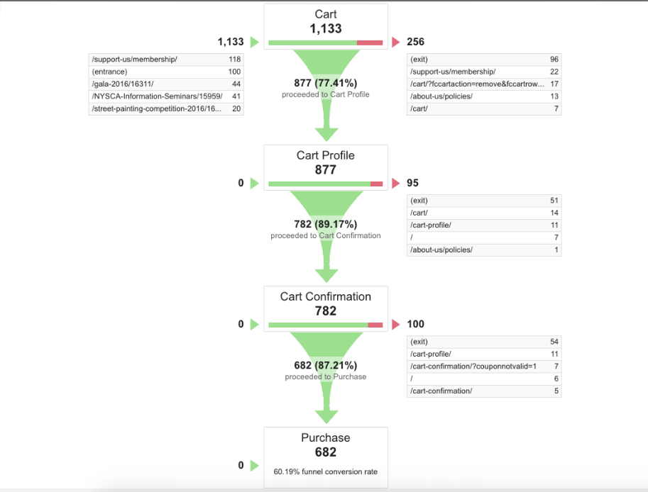

**4) STEPS REQUIRED FOR INCREASING CONVERSION RATE :**

**a) Questions need to answered before proceeding? :**

Market conversions requires proactive engagement with customers; Marketers has to answer the following questions before trying for conversion –

1. Who am I trying to convert?

2. What am I trying to convert them to ?

3. What is the true objective I am trying to accomplish ?

**b) Strategies for achieving Conversion :**

Common Conversion strategies –

**1) Recommendations :** Behavioural Analysis that identifies products and services relevant to customers and recommend that to our customer.

**2) Targeted Offers :** Targeting a particular customer segment to promote a good based on behavioural and demographic information.

**3) Ratings & Review :** If customer reviews and ratings are used that will help new customers for buying a good and increase conversion rate.

**4) Personalized Emails :** Emails of recommended goods that are suitable for a customer will give hits and move towards a conversion.

**5) Chat :** Customers who abandon a site are targeted and chatting with them knowing the problem for existing and help them in guiding to solve their problem or fixing the issue will have conversion for these type of customer segments.

**6) Click-to-Call :** It helps customers to directly interact with the marketers.

**7) Co-browsing tools :** web site having Tools which assist customers in online transactions results in a better conversion.

**8) Voice of customer :** Feedback given by customer either by filling forms or by reviewing or rating a particular product will help in understanding the customer behaviour patterns and help in Market Conversions.

**9) Automated Guides**

**10) Re-Targets :** Previous customers again targeted by giving a suitable ad.

**Note :** Generally for an e-commerce website a conversion rate of below 2% is treated as poor and anything above 4% is treated as good.

**References :**

<https://en.wikipedia.org/wiki/Conversion_marketing>

<http://sherpablog.marketingsherpa.com/marketing/conversion-defined/>

<https://megalytic.com/blog/understanding-the-funnel-visualization-in-google-analytics>